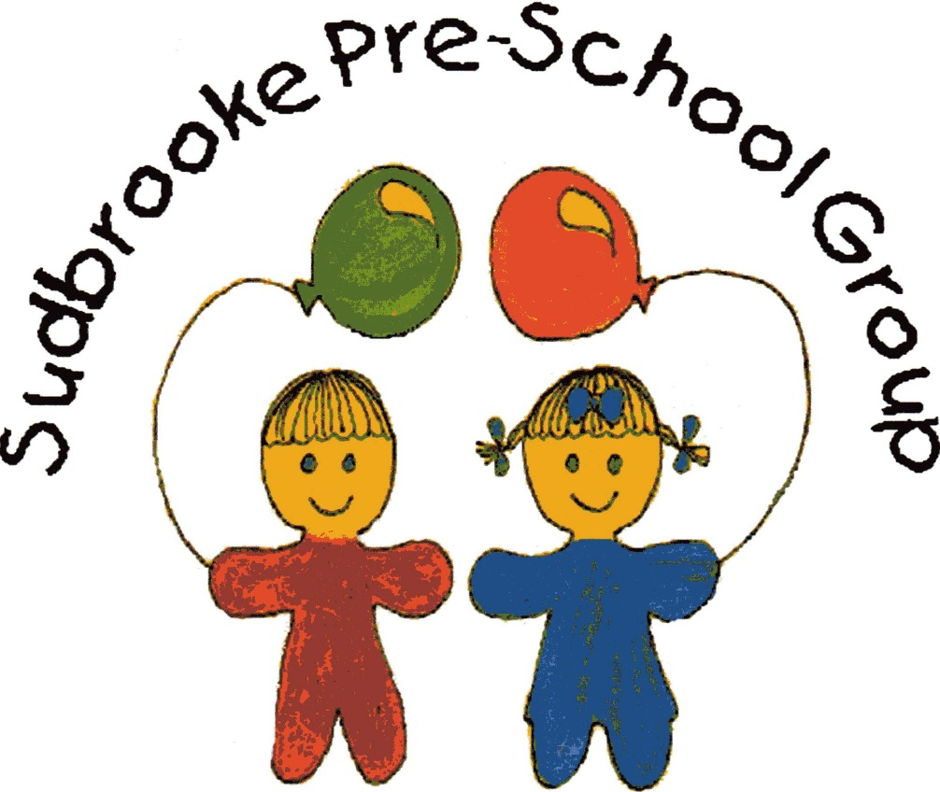

Information Pack

Sudbrooke Pre-School Group

A member of the Pre-school Learning Alliance and OFSTED inspected

Sudbrooke Pre-School Group

We would like to take this opportunity to welcome your family to Sudbrooke Pre-School Group.

Sudbrooke Pre-school Group was first established in 1987 and operates from Sudbrooke Village Hall, serving the children and families of Sudbrooke and the surrounding villages. Our sessions are as follows.

**Monday, Tuesday, Wednesday and Thursday: 9.00am to 12.00pm and 12.00pm to 3pm**

**There is also the option for the children to stay for the lunch hour which is 12.00pm to 1pm.**

Our pre-school terms coincide with dates as issued by the LEA which also coincide with Ellison Boulters School. We occasionally close for staff training days or when the village hall is used as a polling station. Term dates are displayed on our notice board, along with other information and updates and is located in the entrance hall during sessions. In the event of unforeseen closure, families will be contacted by telephone and a post will be uploaded onto our Facebook page and Tapestry Memo.

The pre-school is registered to cater for a maximum of 24 children in any one session. Children can join pre-school at 2 years of age and we do not require them to be toilet trained. We provide funded early years education for three- and four-year-olds and support children with English as an additional language and children with Special Educational Needs or disabilities.

We encourage new parents/carers to visit our pre-school with their child to gain an insight into our routines, activities and objectives. It offers an opportunity for the child to familiarise themselves with the environment, staff, and other children. It also provides the parents with time to raise questions, discuss concerns or express any individual needs for their child. We welcome parents into our group at any time, but in order to ensure that the manager is available to meet new parents/carers, we would recommend making an appointment. For further information or to arrange a visit, please contact Sudbrooke Village Hall on 01522 754047 during session times and ask to speak to Laura, the manager or email at [Sudbrookepreschool@googlemail.com](mailto:Sudbrookepreschool@googlemail.com).

# Early Years Entitlement (EYE)

EYE is available at all sessions.

EYE is available term time only (over 38 weeks of the year)

Funded childcare of 15 or 30 hours is available in the funding term **following** their second and third birthday.

Attendance over these hours for funded children will incur an additional charge. Full details regarding funding can be obtained from the manager and we will require you to complete some forms supplied by us in order to receive the funding. We are also registered to accept Childcare vouchers and we are registered on the tax-free childcare scheme, details of which are available from the Manager.

Parents will be required to provide evidence of the child’s date of birth and complete a funding declaration form. Parents are responsible for obtaining or renewing eligibility codes to access government funded childcare.

Allocation of places will be in order of date of birth. Priority will be given to children of eligible age for Early Years Education Entitlement. Wherever possible, a month’s notice of your intention to withdraw your child from the group should be given.

**Fees**

Session rates:

£18 (3 hours)

£6 (1 hour lunch)

£36 (6 hours- 2 sessions)

**Invoices**

The manager or deputy manager will issue individual bills to parents/carers via email. We accept fee payments via BACs. Detail of which are on the monthly bill.

We regret that refunds are only made in exceptional circumstances. Should your child be unable to attend pre-school for whatever reason, including sickness and holidays, the session **must still be paid for**. We are committed to ensuring that children and their families are not discriminated against on financial grounds. We will therefore offer a flexible payment system should it be required, information regarding this can be obtained from the Manager.

**Staff Members**.

### Staff

###### Manager Mrs Laura Hutchinson

###### Deputy Manager Mrs Kelly Tyrrell

## Assistants Mrs Catherine Goodman

Mrs Freya Read

## 

## Bank Staff Miss Emily Cooper

## Mrs Vicki Timings-Thompson Mrs Olwen Edwards

**Special Educational Needs** Mrs Laura Hutchinson

**Co-ordinator (SENco)**

**Safeguarding Officer** Mrs Kelly Tyrrell

We adhere to current Ofsted staffing requirements which state that the minimum staffing ratios are:

Children aged 2 years 1 adult to every 5 children.

Children aged 3 to 7 years 1 adult to every 8 children.

It is our intention whenever possible to exceed these ratios in order to provide a high level of adult assistance, support and guidance for the children in our care.

**Management**

Our pre-school is run by an elected management committee, consisting of parents/carers or members of the community, who volunteer their time and services to the group. The management committee is made up of the Chairperson, Treasurer and Secretary, as well as general committee members, elected at the Annual General Meeting (AGM). The committee meet informally every 6-8 weeks, to discuss topics such as staffing and recruitment, finances, and fundraising initiatives.

**The support, involvement and contributions parents/carers make is essential to the smooth running and existence of our pre-school group.**

**Our Sessions**

Our sessions are organized so that the children are provided with a balance between more structured activities that may require a greater degree of adult support and free play which is more child directed. Such activities allow children time to explore, play and learn independently, with adult support when necessary. The children have opportunities to play and learn on a one-to-one basis, in small groups with their key person and to participate in whole group activities, both indoors and outdoors. There is a balance between quiet times, e.g. listening to a story and the more energetic play such as ride on toys or the use of the play park. All sessions are tailored to suit individual needs, abilities and interests and at this stage the emphasis is still very much on learning through play.

**Key Person and Progress Records**

Each child is assigned a key person after the first few weeks of attending pre-school: this means that each child w**ill** have a designated key person whose role is to help ensure that every child’s care is tailored to meet their individual needs, to help the child become familiar with the setting, offer a settled relationship with the child, and build a relationship with their parents. It also provides parents/carers with an initial point of contact; however, all members of staff are responsible for the involvement and wellbeing of every child attending on all sessions.

# During a child’s time at pre-school the key person will observe, assess and record their progress. This enables us to understand the needs of individual children and provides us with the information we require in order to extend their learning and development. It is our intention for all children to be given the opportunity to achieve. Your child’s progress and development is recorded in their individual Tapestry online Learning journey, which is freely available for parents/carers to view and contribute to.

**Progress Check at Age Two**

The Progress Check at age two requires that parents/carers are supplied with a short, written summary of their child’s development in the three prime learning and development areas of the EYFS. The purpose of the progress check is to describe your child’s current level of development, but more critically, to identify any aspects that may indicate developmental concerns and how these are being addressed.

This statutory requirement states that the progress check must take place between the ages of 24– 36 months. The timing of the check will also be dependent on patterns of attendance. Practitioners will need to build up a clear picture of your child before being able to write the report.  The progress check will be carried out by a practitioner who knows your child well and works directly with them. This will usually be your child’s key person.The progress check will involve a range of viewpoints from your child, parents, other practitioners within the setting and other professionals who may work with your child.

**Policies and Procedures**

Below is a brief outline of some of our policies and procedures, full copies are available at any time during pre-school sessions. Parents/carers may also request to have a copy of them emailed to them.

In particular we would draw your attention to the;

* **Confidentiality Policy:**  We are conscious of the fact that personal information regarding a child, their family and staff is given to us in the form of records, conversations and in meetings. We take every step to ensure that an individual’s right to privacy and confidentiality is upheld.
* **Safeguarding Children Policy:** The welfare, safety and protection of children are of paramount concern to us and we are committed to providing an environment in which children are safe from abuse. Any suspicion of abuse will be dealt with sensitively and appropriately in order to ensure the safety of the child.
* **Additional Needs:** We recognize that all children have different needs and that some children have a special educational need or a special need relating to a medical condition or disability. Our aim is to work in partnership with the parents/carers and child to provide care, play and learning opportunities best suited to their needs, so that they can progress and achieve. We are committed to following the Government’s *SEN Code of Practice*. If any concern with a child’s development is considered, the supervisor will discuss these concerns with the child’s family or carer. Early Years and Childcare support (EYCC) will be contacted with any concerns but only with prior permission from the parents/carers, who will of course be given the opportunity to discuss any concerns directly with EYCC.
* **Behaviour Management Policy:** Children should be free to play and learn without fear of being hurt, hindered, or threatened by peers or adults and achieve their best in an environment that is ordered and in which they understand what is expected of them. It is our intention for children to feel safe and happy; this is in part achieved through a consistent approach to managing behaviour, mutual respect, praise, and encouragement.
  + **Complaints Procedure:** We welcome suggestions and comments from parents/carers and believe that most complaints are made constructively. All complaints will be taken seriously, dealt with promptly and fairly, in a way that respects confidentiality.

**General Information:**

**Water bottles**

In order that your child can access a drink throughout the morning/afternoon as required, it is requested that a named bottle of water is provided from home. We can re-fill these during your child’s time at preschool.

**Packed Lunches**

In line with our Healthy Eating Policy, we would encourage those children that stay for a packed to be provided with healthy choices. Any uneaten food will be sent home in their lunch box in order that you can be informed on what they have eaten. We encourage the use of cool packs, particularly in the warmer weather.

For a charge of £6.00, we welcome any children to stay for an additional lunchtime session. These extra sessions will be invoiced at the end of each month.

**Clothing/Footwear**

# We ask parents/carers to consider the suitability of certain clothing and footwear for pre-school. For example, clothing that is easy for your child to manage when going to the toilet (in order to encourage independence) and ordinary shoes, plimsolls or trainers rather than open toe sandals, which do not provide adequate protection. We make use of the outdoor area, including the play equipment, the field, our garden area and the patio, which allows for free access to the outdoors, so please could you provide sensible footwear/clothing according to the weather. Please label all clothing/personal belongings with your child’s name.

**‘Dress for mess!’** Our children have lots of sensory play activities, so please dress your child for ‘mess’ so they can enjoy these activities to the fullest. We do provide aprons but sometimes some children aren’t too keen on wearing them so dressing for mess is the safest option to save their best clothes getting stained.

If your child is toilet training, we ask that you provide at least 2 pairs of pants/knickers, trousers, and socks etc. This then ensure we have plenty of spare clothes should we need to change your child during the session, thank you.

We do have uniform available to purchase at the setting:

Polo T-shirt are £8

Sweatshirts are £10

